BREAKFAST & AFTERSCHOOL CLUB MENU
 | BREAKFAST CLUB | AFTER-SCHOOL CLUB
MONDAY | Choice of Cereals, Pancakes or Crumpets  Milk, Orange Juice, Apple Juice or Water | Choice of Banana, Tangerine, Apple, Rice Cakes, Crackers, Biscuits, Pancakes or Crumpets  Milk, Orange Juice, Apple Juice or Water
TUESDAY | Choice of Cereals, Pancakes or Crumpets  Milk, Orange Juice, Apple Juice or Water | Choice of Banana, Tangerine, Apple, Rice Cakes, Crackers, Biscuits, Pancakes or Crumpets  Milk, Orange Juice, Apple Juice or Water
WEDNESDAY | Choice of Cereals, Pancakes or Crumpets  Milk, Orange Juice, Apple Juice or Water | Choice of Banana, Tangerine, Apple, Rice Cakes, Crackers, Biscuits, Pancakes or Crumpets  Milk, Orange Juice, Apple Juice or Water
THURSDAY | Choice of Cereals, Pancakes or Crumpets  Milk, Orange Juice, Apple Juice or Water | Choice of Banana, Tangerine, Apple, Rice Cakes, Crackers, Biscuits, Pancakes or Crumpets  Milk, Orange Juice, Apple Juice or Water
FRIDAY | Choice of Cereals, Pancakes or Crumpets  Milk, Orange Juice, Apple Juice or Water | Choice of Banana, Tangerine, Apple, Rice Cakes, Crackers, Biscuits, Pancakes or Crumpets  Milk, Orange Juice, Apple Juice or Water

ALLERGEN INFORMATION
SNACKS
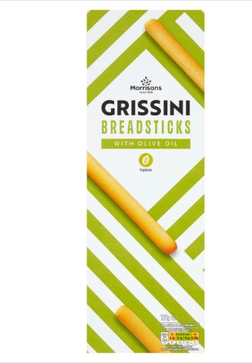 | 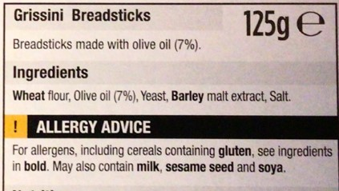
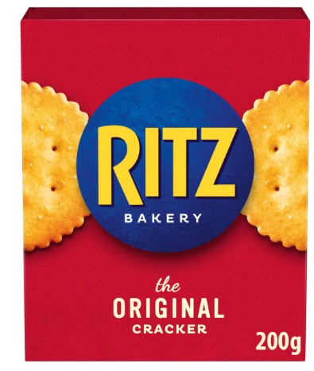 | 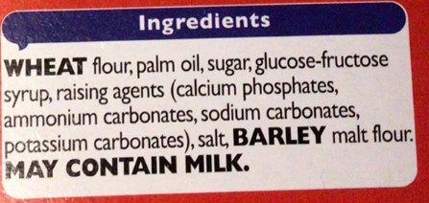
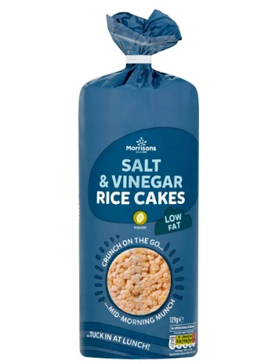 | 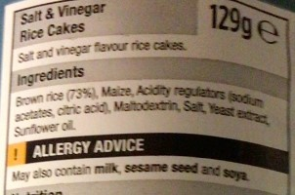
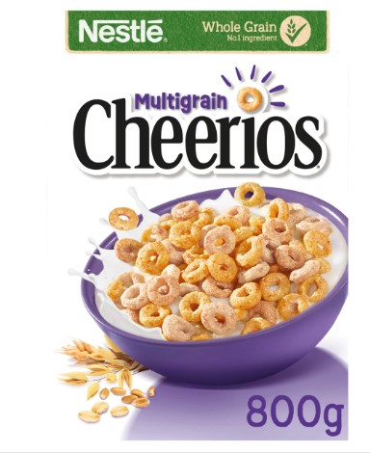 | 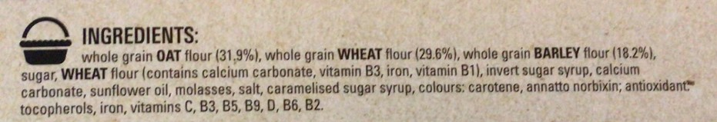
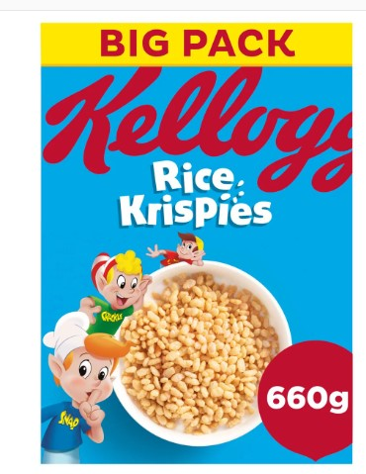 | Ingredients  Rice, Sugar, Salt, Barley Malt Extract, Niacin, Iron, Vitamin B6, Riboflavin, Thiamin, Folic Acid, Vitamin D, Vitamin B12  Dietary Information  Contains Barley, May Contain Cereals Containing Gluten
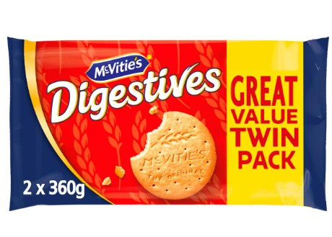 | 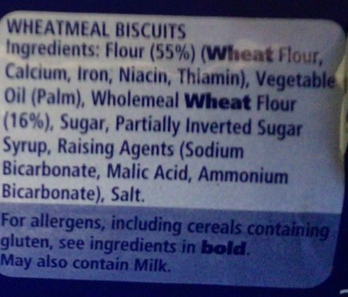
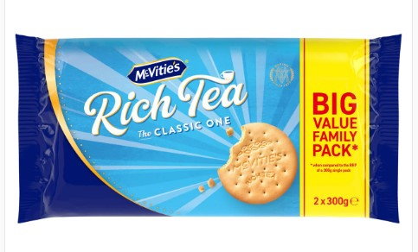 | 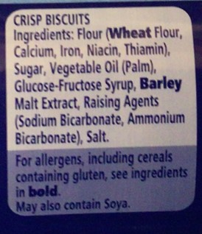
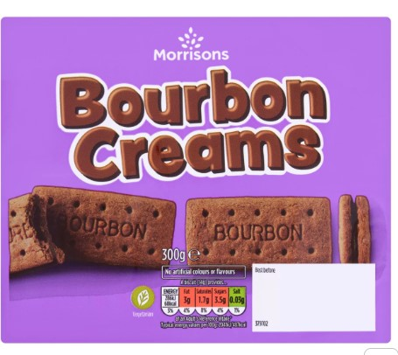 | 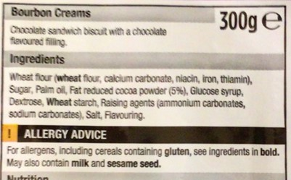
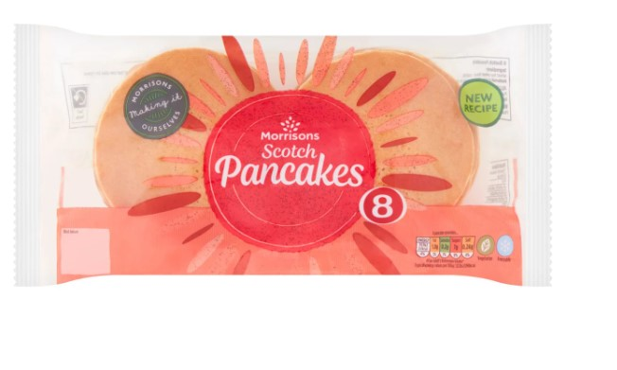 | Dietary Information  May Contain Cereals Containing Gluten, Contains Eggs, Contains Milk, May Contain Soya, Contains Wheat  Ingredients  Wheat Flour (Wheat Flour, Calcium Carbonate, Iron, Niacin, Thiamin), Water, Sugar, Rapeseed Oil, Humectant (Glycerol), Buttermilk Powder, Dried Egg, Raising Agents (Diphosphates, Potassium Carbonates), Salt, Preservative (Calcium Propionate)
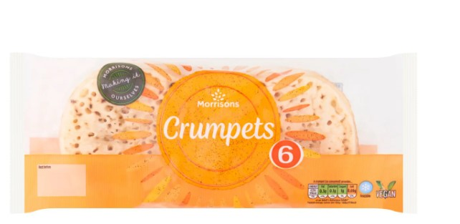 | 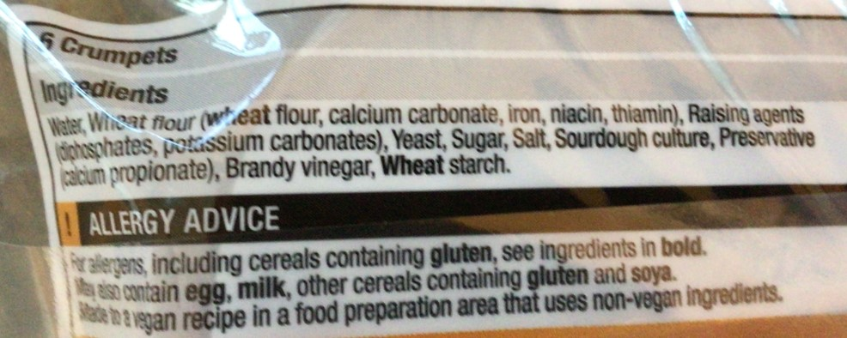
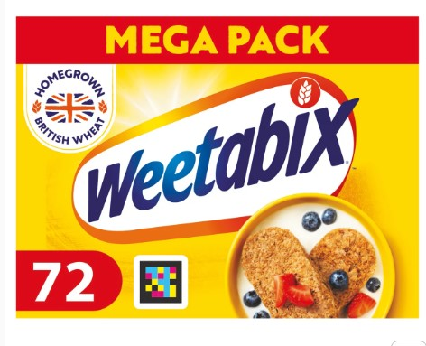 | 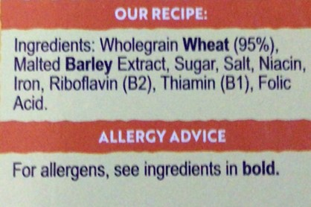
MILK AND MILK ALTERNATIVES
We use Cool Milk as our school milk Supplier | Further information can be found by visiting https://coolmilk.com/
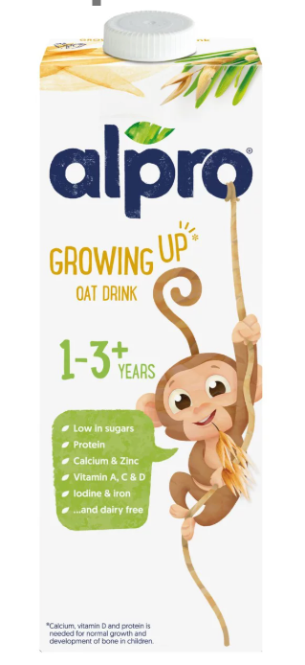 | Ingredients  Oat Base (Water, Oat (7,8%)), Vegetable Oils (Rapeseed, Sunflower), Pea Protein, Maltodextrin, Calcium (Calcium Carbonate), Natural Flavour, Acidity Regulator (Potassium Phosphates), Stabiliser (Gellan Gum), Iron, Potassium Iodide, Zinc, Vitamins (A, B2, B9, B12, C, D2)
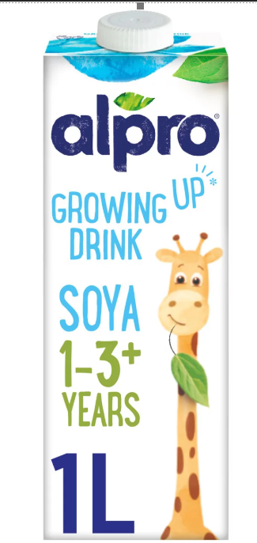 | Ingredients  Soya Base (Water, Hulled Soya Beans (6.6%)), Maltodextrin, Raw Cane Sugar, Fructose, Sunflower Oil, Calcium (Calcium Carbonate), Acidity Regulator (Potassium Phosphates), Flavourings, Emulsifier (Lecithins (Sunflower)), Stabiliser (Gellan Gum), Iron Pyrophosphate, Potassium Iodide, Vitamins (B2, B12, C, D2)

JUICES
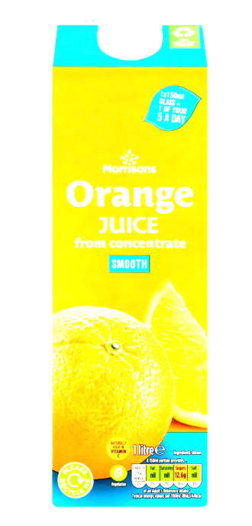 | Ingredients  Orange Juice from Concentrate
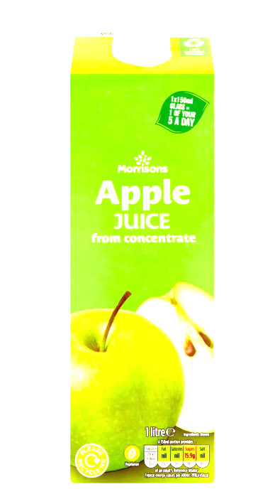 | Ingredients  Apple Juice from Concentrate

