SNACK MENU
 | SAVOURY | FRUIT | DRINK
MONDAY | Breadsticks | Choice of banana, tangerine or apple | Milk or Water
TUESDAY | Ritz Crackers | Choice of banana, tangerine or apple | Milk or Water
WEDNESDAY | Rice Cakes | Choice of banana, tangerine or apple | Milk or Water
THURSDAY | Cheerios | Choice of banana, tangerine or apple | Milk or Water
FRIDAY | Biscuits | Choice of banana, tangerine or apple | Milk or Water

ALLERGEN INFORMATION
SNACKS
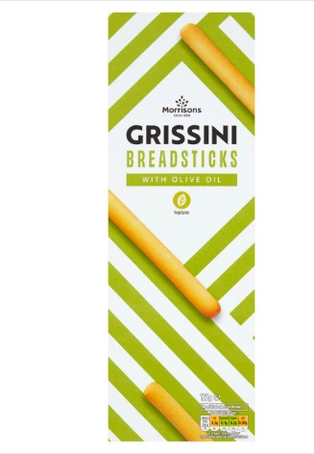 | 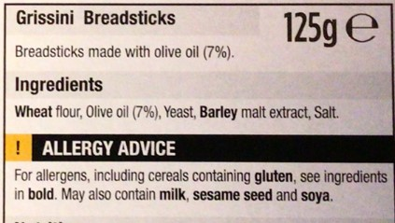
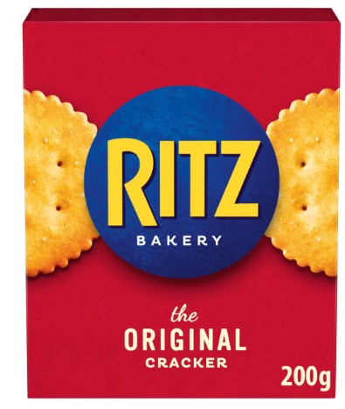 | 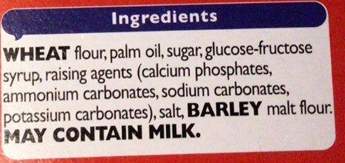
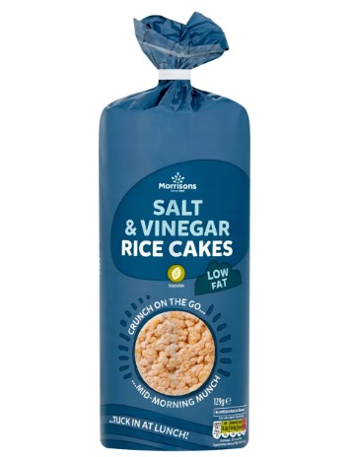 | 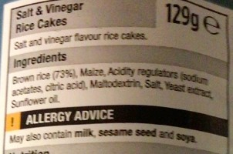
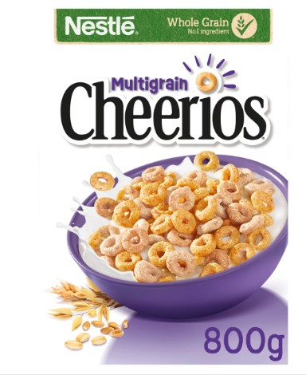 | 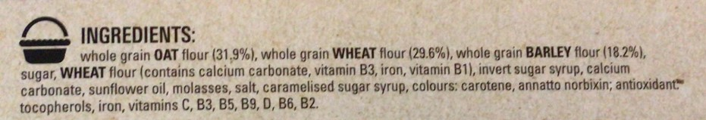
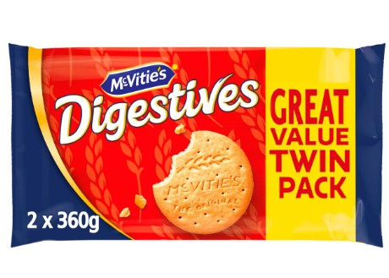 | 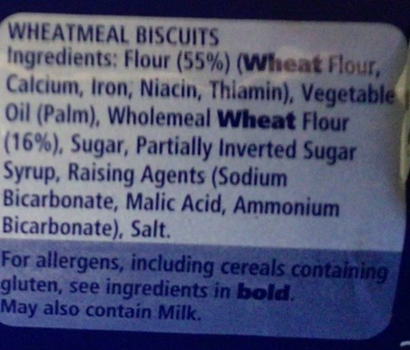
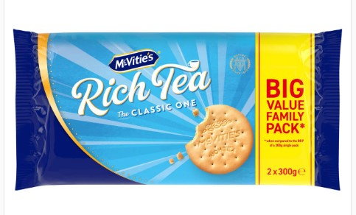 | 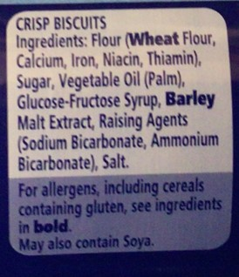
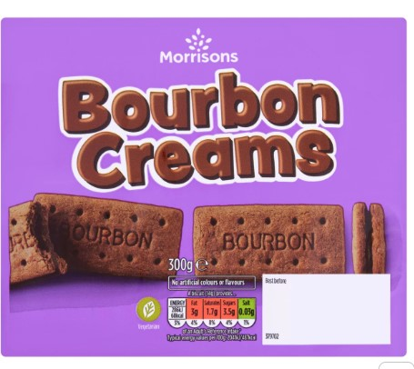 | 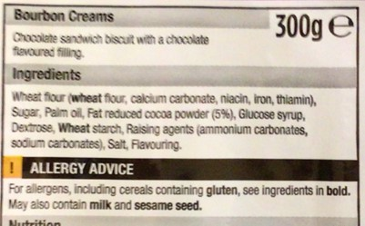
MILK AND MILK ALTERNATIVES
We use Cool Milk as our school milk Supplier |  | Further information can be found by visiting https://coolmilk.com/
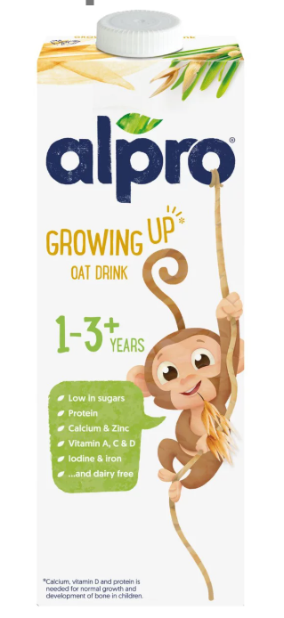 |  | Ingredients  Oat Base (Water, Oat (7,8%)), Vegetable Oils (Rapeseed, Sunflower), Pea Protein, Maltodextrin, Calcium (Calcium Carbonate), Natural Flavour, Acidity Regulator (Potassium Phosphates), Stabiliser (Gellan Gum), Iron, Potassium Iodide, Zinc, Vitamins (A, B2, B9, B12, C, D2)
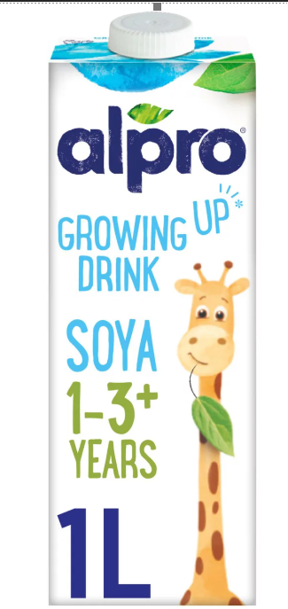 |  | Ingredients  Soya Base (Water, Hulled Soya Beans (6.6%)), Maltodextrin, Raw Cane Sugar, Fructose, Sunflower Oil, Calcium (Calcium Carbonate), Acidity Regulator (Potassium Phosphates), Flavourings, Emulsifier (Lecithins (Sunflower)), Stabiliser (Gellan Gum), Iron Pyrophosphate, Potassium Iodide, Vitamins (B2, B12, C, D2)

JUICES
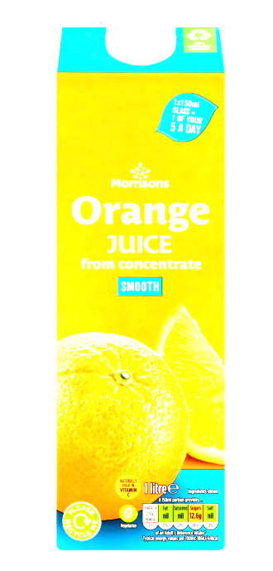 |  | Ingredients  Orange Juice from Concentrate
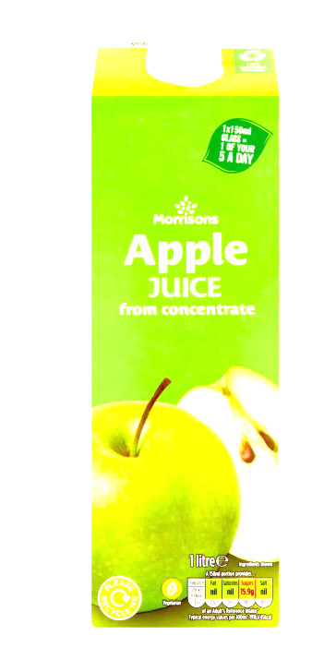 |  | Ingredients  Apple Juice from Concentrate

